CST8116 Pre-Lab Exercise 01 Solution
Last Revision 7 Sep 2024 D. Haley

Task 1 – Problem Solving
Step 1: Ask the user for the two numbers, number1 and number2
Step 2: Sum the two numbers using the formula sum = number1 + number 2
Step 3: Output the sum

Arithmetic example: with number1 = 42 and number2 = 8, sum = 42 + 8 = 50

Task 2 – Pseudocode
start
Declarations
num number1
num number2
num sum
output "Enter number 1 "
input number1
output "Enter number 2 "
input number2
sum = number1 + number2
output "Sum is: ", sum
stop

Task 3 – Testing
Input | Expected Output | Actual Output | Description
42  8 | Enter number 1  Enter number 2  Sum is: 50 | Enter number 1  Enter number 2  Sum is: 50 | Testing method main logic, should ask for two inputs, then output sum of entered numbers.  Logic was verified by hand-tracing pseudocode.

Task 4 – Flowchart

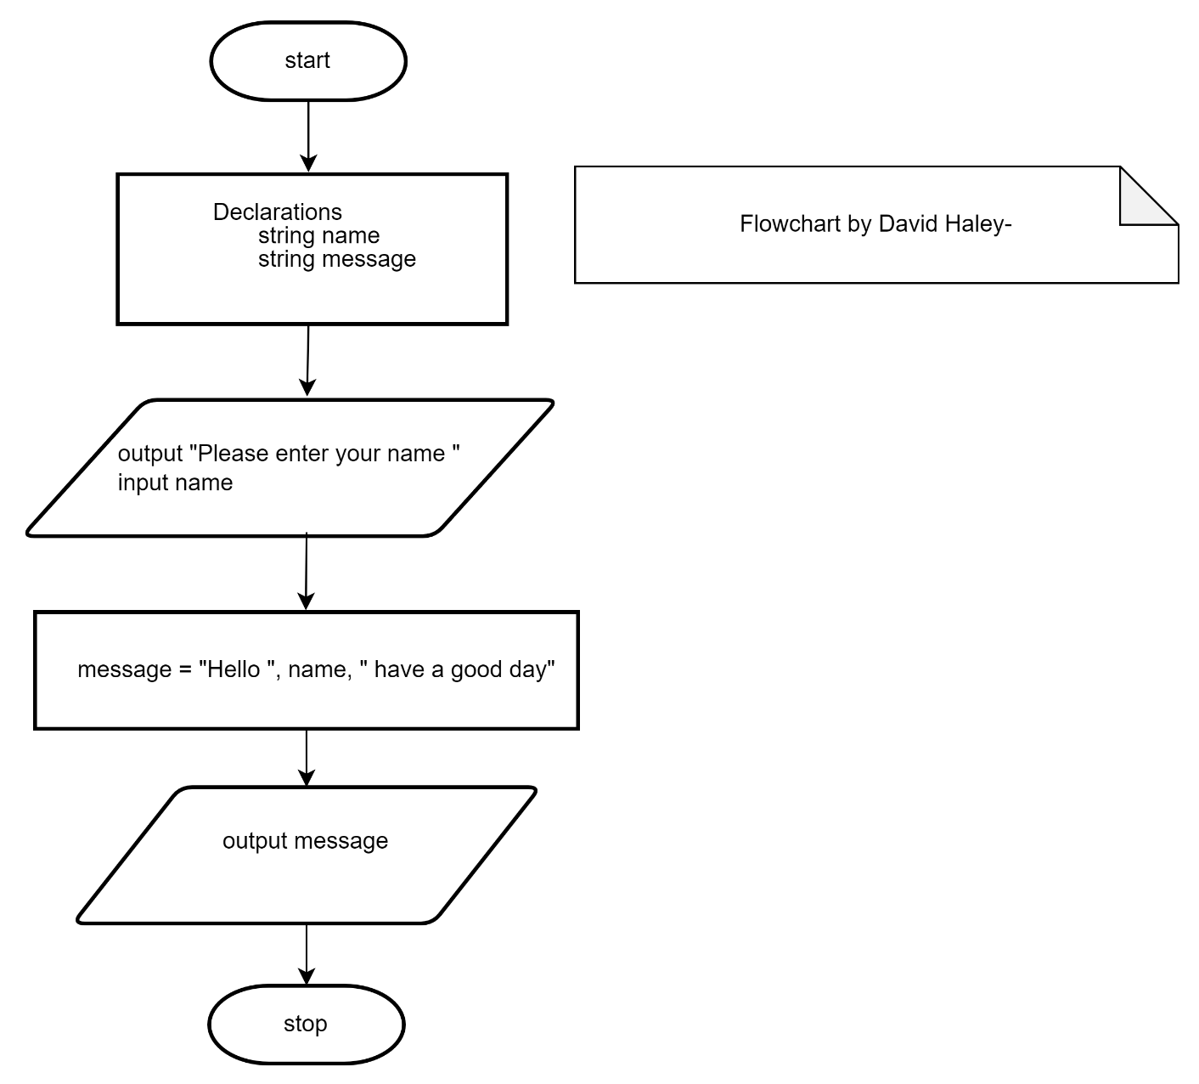

Task 5 – Java Program
